CS454 TERM PROJECT

Can Sölömbaz
Industrial Engineering
Ozyegin University
Istanbul, Turkey
Mert Dedeköy
Electrical and Electronics Engineering
Ozyegin University
Istanbul, Turkey

Abstract— Machine Learning algorithms have a crucial role in classifying images. There are various types of methods are used for this. In this project, it is tried to classify Fashion MNIST Dataset using Nearest Mean Classifier, K-Nearest Neighbor Classifier, Support Vector Machines, Multi-Layer Perceptron Classifier and Convolutional Neural Networks. After the methods estimated the types of clothes, an ensemble method voting is used to reach better results.

Introduction
The project has an objective of classifying types of clothes using Fashion MNIST Dataset. There are 60,000 examples of training data and 10,000 examples of test data. Each example is 28x28 greyscale image and each image has a label. The labels are t-shirt/top, trouser, pullover, dress, coat, sandal, shirt, sneaker, bag, and ankle boot.
There are various classification approaches on Kaggle and other platforms on Fashion MNIST dataset. We propose 3 methods below for benchmark and 3 methods to reach higher accuracy.
1 - Nearest Mean Classifier (NM)
2 - K-Nearest Neighbor Classifier (KNN)
3 - Support Vector Machines (SVM)
To get higher accuracy, we propose to use;
4 - Multi-Layer Perceptron Classifier (MLP)
5 - Convolutional Neural Networks (CNN)
6 – Ensemble Method

Methods

Nearest Mean Classifier

NM is a parametric classification method that classify the test data based on distance to the mean of each training classes. In this project, the mean images of the types of clothes are found using pixel values of the instances from the training data. In order to test each instance both from training and test data are classified according to the nearest mean images. The distances between mean images and instances are compared using the sum of squared errors. When similar clothes are classified, such as shirts, t-shirts, and pullovers, there are much higher errors as their mean images are closer to each other. However, shoes and clothes are separated clearly. Mean images, confusion matrices of training and test data are shown in Fig. 1, Fig. 2 and Fig. 3 accordingly. Test data have 1000 examples on the other hand training data have 6000 examples from each class. Test accuracy is 68.57.

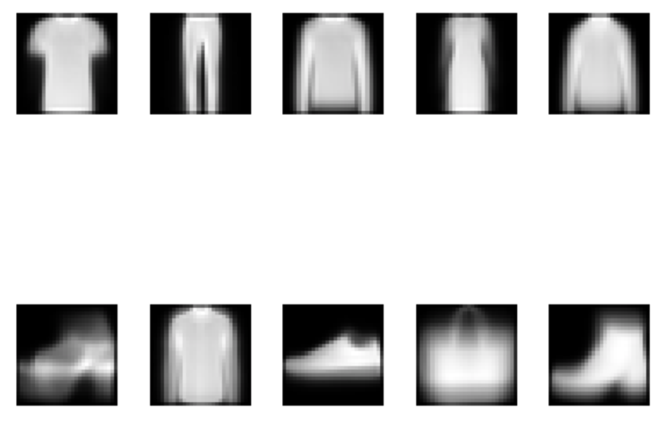

Fig. 1. Mean Images of Training Data
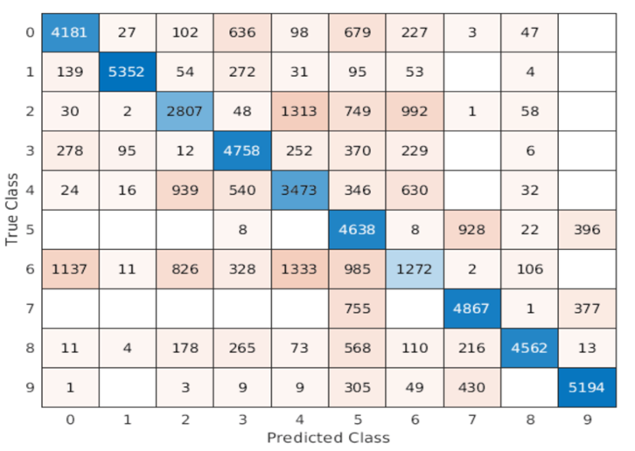

Fig. 2 Confusion Matrix of NM for Training Data
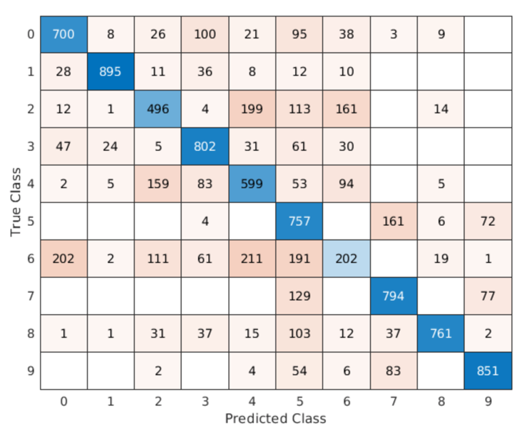

Fig. 3 Confusion Matrix of NM for Test Data

K – Nearest Neighbor Classifier
It is a non-parametric method that classifies the images by looking at the closest hyperparameter K number neighbor. Test example’s class is chosen according to majority of the neighbors’ class. In this paper, firstly training data are splitted 50000 for training 10000 for validation. For validation data, K value is tried from 1 to 6 to see which one gives better validation results. As it is seen from Fig. 4 when K value is chosen 4, it gives better accuracy. Next, for each test example nearest 4 instances from training data are taken and the most appeared class in them is assigned to test example. Sum of squared errors are used for distance metric. The overall accuracy is for test data is 86.62%. Every class has 5000 instances for training data and 1000 example for test data. The confusion matrices of training and test data are in Fig. 5 and Fig. 6.

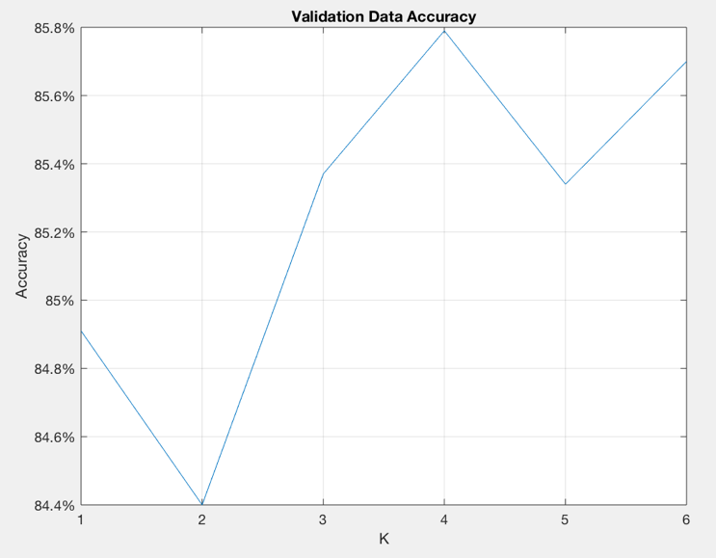

Fig. 4 Validation Data Accuracy Depends on K

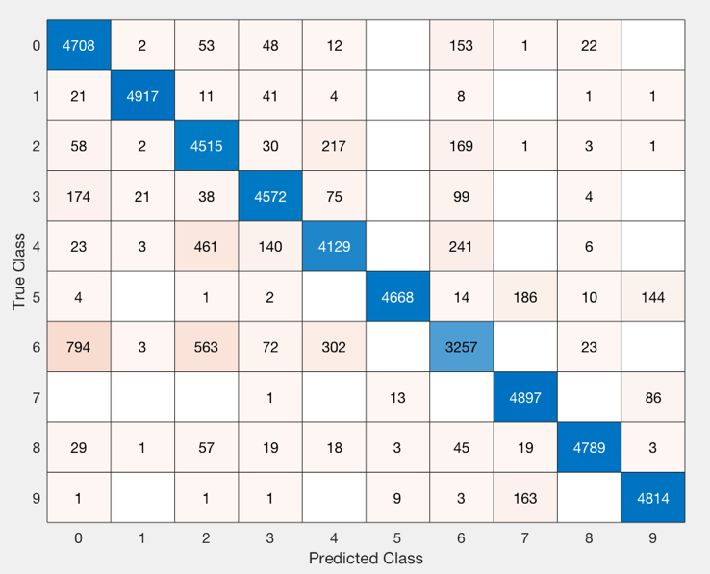

Fig. 5 Confusion Matrix of KNN for Training data

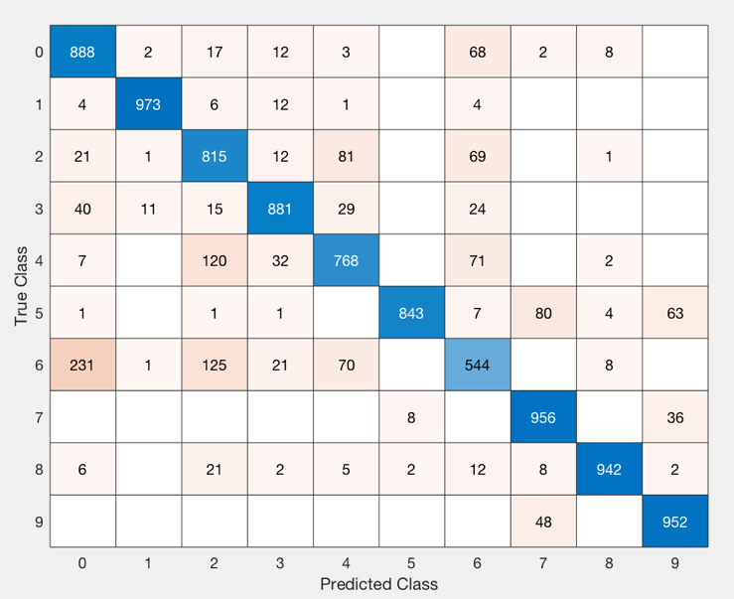

Fig. 6 Confusion Matrix of KNN for Test data

Support Vector Machines
Svm is conducted with sklearn library in Python. Due to very large dataset, computational power is not enough to finish training in 12 hours. The process was stopped because of heating on computer. Another CNN is built instead of svm as it can be seen in section E.

Multi Layer Perceptron Classifier
MLP is proposed to reach higher accuracy in our paper. The method takes 785-dimensional input which is 28*28 input vector and a bias. There is one hidden layer in the architecture which includes 50 hidden units. A sigmoid function is used to conduct nonlinear classification in the hidden layer. Output layer takes 50-dimensional hidden layer and predict 10 classes by a softmax function. 0.2 of hiden layer outputs dropped out and weight decay is used to reduce overfitting and improve generalization error.
Weights are updated during 40 epochs. Fig 7 demonstates negative likelihood loss during 40 epoch. 60000 instances is used for training and 10000 instances used for testing the model. The overall accuracy for test data is 88.12%.
Fig 8 illustrates the class predictions for test data.

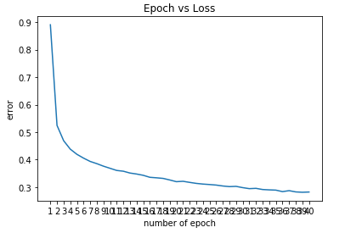
Fig. 7 Epoch vs Loss during MLP training
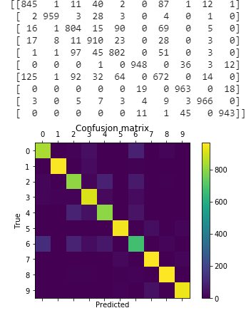
Fig. 8 Confusion Matrix of MLP for Test Data

Convolutional Neural Networks
Different architectures of CNN’s were studied to improve accuracy. After trial and error 3 CNN are proposed in this paper. First one is inspired by LeNet-5. 3 convolutional layers and 2 max-pool between convnets are placed. Then final layer is flattened and 2 fully connected layers are built. First convnet consists 6 filters with size 5 and stride 1, second convnet has 16 filters with size 5 and stride 1, last convnet has 120 filters with kernel size 4 and stride 1. No padding is applied in convnets. Fully connected layers take 120 features
and 84 features as input respectively. A softmax function is used for classification. Relu is used as activation function in all layers. This CNN is called as CNN-1 and it has accuracy of 0.8967 on test data. Fig 9. illustrates classification results on test instances.
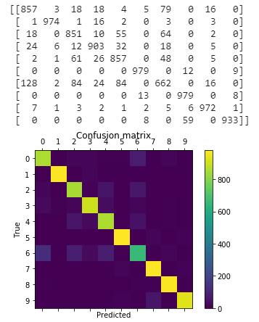
Fig. 9 Confusion Matrix of CNN-1 on Test Data

CNN-2 is built with a different architechure. It has 2 convnets, 2 maxpool, a flatten operation and 2 fully connected layers. First convnet comprises 32 filters with kernel size 5, stride 1 and padding 2. Second convnet has 64 filters with kernel szie 5, stride 1 and padding 2. 2 maxpool is conducted after convnets. First fully- connected layer takes 64*7*7 input and 1000 hidden outputs whereas second fully connected layer takes 1000 input and 10 hidden outputs. Then softmax is used for classification. Also, half of the hidden outputs are dropped out after first fully connected layer. The network has accuracy of 0.9211. Fig 10 illustrates classification results on test data.

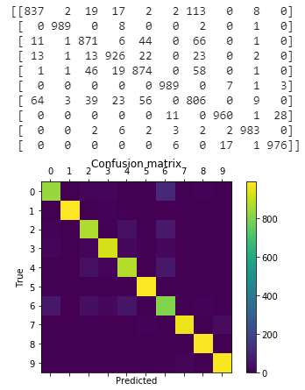
Fig 10. Confusion Matrix for CNN-2 on Test Data

CNN-3 has the same architecture with CNN-2 but it uses batch normalization instead of dropout. Batch normalization is conducted after first convnet and first fully connected layer. CNN-3 has the accuracy of 0.9144. Compared with CNN-2, using dropout gave better result than batch normalization for regularization purposes. Fig 11 demonstrates classification results for test data.
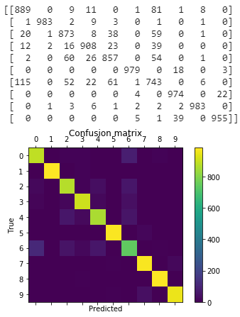
Fig. 11 Confusion Matrix for CNN-3 on Test Data

Ensemble Method
After Fashion MNIST test data classified by each method, voting ensemble method is implemented. It is applied in two cases. First, it applied onto 3 CNN and MLP Classifiers. Results of methods are compared and whichever class is voted most, is assigned as prediction to the test example. Previous accuracy rates for CNN’s are 89.67%, 92.11%, 91.44% and MLP has 88.12%. After voting, test accuracy increases up to 92%. In second case, MLP is removed and 3 CNN’s are ensembled. In this case, test accuracy increased to 92.6%. In Fig. 12, it shows the confusion matrix for test data after first voting and Fig. 13 shows confusion matrix after second voting.
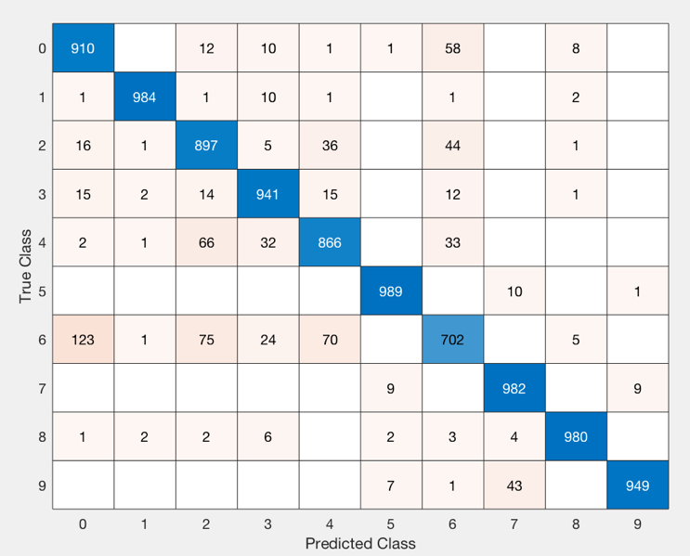
Fig. 12 Confusion Matrix for Test Data After First Voting

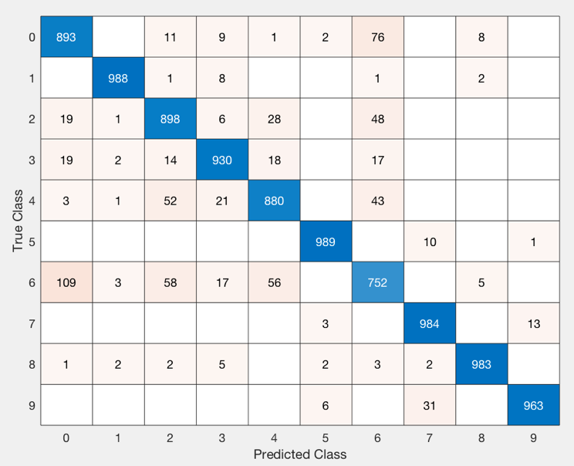
Fig. 13 Confusion Matrix for Test Data After Second Voting

Results

After implementing all the methods, final result table can be seen in below.

Methods | Results
Nearest-Mean Classifier | 0.6857
K-Nearest Neighbor | 0.8662
Multi-Layer Perceptron | 0.8812
CNN-1 | 0.8967
CNN-2 | 0.9211
CNN-3 | 0.9144
Ensemble-with MLP | 0.92
Ensemble-without MLP | 0.926

Appendıx
PYTHON
import torch
from torch import nn
import torch.nn.functional as F
from torchvision.datasets import FashionMNIST
from torch.utils.data import DataLoader
from torchvision import transforms
from torch.autograd import Variable
from torchvision.utils import save_image
from sklearn.metrics import confusion_matrix
from matplotlib import pyplot as plt
from matplotlib import cm as cm
import pandas as pd
import numpy as np
from sklearn.metrics import accuracy_score

from sklearn.svm import SVC

label=[i for i in range(10)]
def conf_matrix(y_pred,y_true,label):
labels=label
cm = confusion_matrix(y_true, y_pred, labels=label)
print(cm)
fig = plt.figure()
ax = fig.add_subplot(111)
cax = ax.matshow(cm)
plt.title('Confusion matrix')
fig.colorbar(cax)
ax.set_xticks(labels)
ax.set_yticks(labels)
ax.set_xticklabels(labels)
ax.set_yticklabels(labels)
plt.xlabel('Predicted')
plt.ylabel('True')
plt.show()

class MLP(nn.Module):
def __init__(self):
super(MLP, self).__init__()

# MNIST image is 1x28x28 (CxHxW)
# Pytorch expects input data as BxCxHxW
# B: Batch size
# C: number of channels gray scale images have 1 channel
# W: width of the image
# H: height of the image

# W after conv2d [(W - Kernelw + 2*padding)/stride] + 1

self.fc1 = nn.Linear(in_features=28*28,
out_features=50)
# self.fc2=nn.Linear(in_features=50,
# out_features=50)

# second fully connected layer from 100 input features to 10 outputs
self.fc2 = nn.Linear(in_features=50,
out_features=10)

self.fc1_drop = nn.Dropout(0.2)
# self.fc2_drop = nn.Dropout(0.2)

def forward(self, x):
x = x.view(-1, 28*28)
x= F.sigmoid(self.fc1(x))
x = self.fc1_drop(x)
x = F.log_softmax(self.fc2(x),dim=1)

return x

class CNN1(nn.Module):
def __init__(self):
super(CNN1, self).__init__()
self.conv1 = nn.Conv2d(in_channels=1,
out_channels=6, kernel_size=5, stride=1, padding=0)

self.maxpool1 = nn.MaxPool2d(2,2)

self.conv2= nn.Conv2d(in_channels=6,
out_channels=16,
kernel_size=5,
stride=1,
padding=0
)
self.maxpool2 = nn.MaxPool2d(2,2)

self.conv3= nn.Conv2d(in_channels=16,
out_channels=120,
kernel_size=4,
stride=1,
padding=0
)

self.fc1 = nn.Linear(in_features=120,
out_features=84)

self.fc2 = nn.Linear(in_features=84,
out_features=10)

def forward(self, x):
x = F.relu(self.conv1(x))
x = self.maxpool1(x)
x = F.relu(self.conv2(x))
x = self.maxpool2(x)
x = F.relu(self.conv3(x))
x = torch.flatten(x,1) # flatten feature maps, Bx (CxHxW)
x = F.relu(self.fc1(x))
x = F.log_softmax(self.fc2(x),dim=1)

return x
class CNN2(nn.Module):
def __init__(self):
super(CNN2, self).__init__()

# W after conv2d [(W - Kernelw + 2*padding)/stride] + 1

self.conv1 = nn.Conv2d(in_channels=1,
out_channels=32,
kernel_size=5,
stride=1,
padding=2)

self.maxpool1 = nn.MaxPool2d(2,2)

self.conv2= nn.Conv2d(in_channels=32,
out_channels=64,
kernel_size=5,
stride=1,
padding=2
)

self.maxpool2 = nn.MaxPool2d(2,2)

self.fc1 = nn.Linear(in_features=64*7*7,
out_features=1000)

self.dropout = nn.Dropout(0.5)

self.fc2 = nn.Linear(in_features=1000,
out_features=10)

def forward(self, x):
x = F.relu(self.conv1(x))
x = self.maxpool1(x)
x = F.relu(self.conv2(x))
x = self.maxpool2(x)
x = torch.flatten(x,1) # flatten feature maps, Bx (CxHxW)
x = F.relu(self.fc1(x))
x = self.dropout(x)
x = F.log_softmax(self.fc2(x),dim=1)

return x

class CNN3 (nn.Module):
def __init__(self):
super(CNN3, self).__init__()

self.conv1 = nn.Conv2d(in_channels=1,
out_channels=32,
kernel_size=5,
stride=1,
padding=2)

self.batchnorm1 = nn.BatchNorm2d(32)

self.maxpool1 = nn.MaxPool2d(2,2)

self.conv2= nn.Conv2d(in_channels=32,
out_channels=64,
kernel_size=5,
stride=1,
padding=2
)

self.maxpool2 = nn.MaxPool2d(2,2)

self.fc1 = nn.Linear(in_features=64*7*7, out_features=1000)

self.batchnorm2 = nn.BatchNorm1d(1000)

self.fc2 = nn.Linear(in_features=1000, out_features=10)

def forward(self, x):
x = F.relu(self.conv1(x))
x = self.batchnorm1(x)
x = self.maxpool1(x)
x = F.relu(self.conv2(x))
x = self.maxpool2(x)
x = torch.flatten(x,1)
x = F.relu(self.fc1(x))
x = self.batchnorm2(x)
x = F.log_softmax(self.fc2(x),dim=1)

return x

num_epochs = 40
batch_size = 128
learning_rate = 1e-3
n_batches = 60000 // batch_size

# normalize each image and set the pixel values between -1 and 1
img_transform = transforms.Compose([
transforms.ToTensor(),
transforms.Normalize((0.5,), (0.5,))])

# prepare data loader
trainset = FashionMNIST('./data', transform=img_transform, download=True)
dataloader = DataLoader(trainset, batch_size=batch_size, shuffle=True)

# determine where to run the code
device = torch.device("cuda" if torch.cuda.is_available() else "cpu")

# print(net) # display the architecture
loss_function = nn.NLLLoss().to(device)

# create an CNN network instance
net = CNN1().to(device)
optimizer1 = torch.optim.Adam(net.parameters(), lr=learning_rate, weight_decay=1e-5)

net2 = CNN2().to(device)
optimizer2 = torch.optim.Adam(net2.parameters(), lr=learning_rate, weight_decay=1e-5)

net3 = CNN2().to(device)
optimizer3 = torch.optim.Adam(net3.parameters(), lr=learning_rate, weight_decay=1e-5)

net4 = MLP().to(device)
optimizer4 = torch.optim.Adam(net4.parameters(), lr=learning_rate, weight_decay=1e-5)

def train(net, loader, loss_func, optimizer):
net.train() # put model in train mode
total_loss = torch.zeros(1).to(device)

for img, target in loader: # next batch
img = Variable(img).to(device) # convert to Variable to calculate gradient and move to gpu
target = Variable(target).to(device)
output = net(img).to(device) # feed forward
loss = loss_func(output, target) # calculate loss
optimizer.zero_grad() # clear previous gradients
loss.backward() # calculate new gradients
optimizer.step() # update weights
total_loss += loss # accumulate loss

return img, output, total_loss

testset = FashionMNIST('./data', transform=img_transform, download=True, train=False)
trainset = FashionMNIST('./data', transform=img_transform, download=True)
test_loader = DataLoader(testset, batch_size=10000, shuffle=False)
train_loader = DataLoader(trainset, batch_size=60000, shuffle=True)

def plot_loss(errors, num_epochs):
num_of_epoch=[i+1 for i in range(num_epochs)]
plt.xticks(num_of_epoch)
plt.xlabel("number of epoch")
plt.ylabel("error")
plt.title("Epoch vs Loss")
plt.plot(num_of_epoch, errors)

errors=[]
for epoch in range(num_epochs):
img, output, loss = train(net, dataloader, loss_function, optimizer1)
errors.append(loss.item()/n_batches)
# log
print('epoch [{}/{}], loss:{:.4f}'
.format(epoch+1, num_epochs, loss.item()/n_batches))
plot_loss(errors, num_epochs)
# save the model
# torch.save(net.state_dict(), './CNN.pth')

def results(model, device, test_loader):
model.eval()
test_loss = 0
correct = 0
with torch.no_grad():
for data, target in test_loader:
data=data.float()
# target=target.float()
data, target = data.to(device), target.to(device)
output = model(data)
test_loss += F.nll_loss(output, target, reduction='sum') # sum up batch loss
pred = output.argmax(dim=1, keepdim=True) # get the index of the max log-probability
confusion_matrix=conf_matrix(pred.cpu(),target.cpu(),label)
accuracy=accuracy_score(target.cpu(), pred.cpu(),normalize=True)
return confusion_matrix,pred.cpu(),accuracy

SVM

from sklearn.svm import SVC
from sklearn.metrics import accuracy_score, confusion_matrix

train=pd.read_csv("C:/Users/mrt/Desktop/ders/cs454/fashion-mnist_train.csv")
test=pd.read_csv("C:/Users/mrt/Desktop/ders/cs454/fashion-mnist_test.csv")

x_train=train.iloc[:,1:].values
r_train=train.iloc[:,0].values
x_test=test.iloc[:,1:].values
r_test=test.iloc[:,0].values

svclassifier = SVC(kernel='rbf')
svclassifier.fit(x_train, r_train)

y_test = svclassifier.predict(x_test)
print(confusion_matrix(r_test, y_test))

MATLAB
T = csvread('fashion-mnist_train.csv',1,0);
Ttest = csvread('fashion-mnist_test.csv',1,0);

mean_numbers = zeros(10, size(T,2)-1);
counters = zeros(10,1);

for i = 1:size(T,1)
for j = 1: size(mean_numbers,1)
if T(i,1) == j-1
mean_numbers(j,:) = mean_numbers(j,:) + T(i,2:end);
counters(j) = counters(j)+1;
end
end
end
mean_numbers = mean_numbers./counters;
zeroM = mat2gray(reshape(mean_numbers(1,:),28,28)');
oneM = mat2gray(reshape(mean_numbers(2,:),28,28)');
twoM = mat2gray(reshape(mean_numbers(3,:),28,28)');
threeM = mat2gray(reshape(mean_numbers(4,:),28,28)');
fourM = mat2gray(reshape(mean_numbers(5,:),28,28)');
fiveM = mat2gray(reshape(mean_numbers(6,:),28,28)');
sixM = mat2gray(reshape(mean_numbers(7,:),28,28)');
sevenM = mat2gray(reshape(mean_numbers(8,:),28,28)');
eightM = mat2gray(reshape(mean_numbers(9,:),28,28)');
nineM = mat2gray(reshape(mean_numbers(10,:),28,28)');
subplot(2,5,1), imshow(zeroM)
subplot(2,5,2), imshow(oneM)
subplot(2,5,3), imshow(twoM)
subplot(2,5,4), imshow(threeM)
subplot(2,5,5), imshow(fourM)
subplot(2,5,6), imshow(fiveM)
subplot(2,5,7), imshow(sixM)
subplot(2,5,8), imshow(sevenM)
subplot(2,5,9), imshow(eightM)
subplot(2,5,10), imshow(nineM)

predicted = zeros(size(T,1),1);
predictedTest = zeros(size(Ttest,1),1);
for i = 1:size(T,1)
error = inf;

for j = 1:size(mean_numbers,1)
if sum((T(i,2:end)-mean_numbers(j,1:end)).^2)<error
predicted(i) = j-1;
error = sum((T(i,2:end)-mean_numbers(j,1:end)).^2);
end

end
end
for i = 1:size(Ttest,1)
errorTest = inf;
for j = 1:size(mean_numbers,1)
if sum((Ttest(i,2:end)-mean_numbers(j,1:end)).^2)<errorTest
predictedTest(i) = j-1;
errorTest = sum((Ttest(i,2:end)-mean_numbers(j,1:end)).^2);
end
end
end
%confusion_matrix_training = confusionchart(T(1:end,1), predicted);
%confusion_matrix_training = confusionchart(Ttest(1:end,1), predictedTest);

accu = 0;
for i = 1:10000
if Ttest(i,1) == predictedTest(i)
accu = accu + 1;
end
end
accu = accu/100;

%% KNN Part

KnearPredict = zeros(10000,6);

for i = 1:10000
kArray = zeros(6,2);
for j = 1:6
kArray(j,1) = T(j,1);
kArray(j,2) = sum((T(j,2:end)-T(i+50000,2:end)).^2);
end

for j = 7: 50000
[Max,I] = max(kArray);

if sum((T(j,2:end)-T(i+50000,2:end)).^2) < Max(2)
kArray(I(2),2) = sum((T(j,2:end)-T(i+50000,2:end)).^2);
kArray(I(2),1) = T(j,1);
end

end
kArray = sortrows(kArray,2);

for j = 1:6
KnearPredict(i,j) = mode(kArray(1:j,1));
end
end

accuracy = zeros(1,6);
for i = 1 : 10000
accuracy(1,:) = accuracy(1,:) + (T(i+50000,1) == KnearPredict(i,:));
end
accuracy = accuracy/100;
figure, plot(accuracy(1,:)); title("Validation Data Accuracy");
xticks(1:6); xlabel("K"); ylabel("Accuracy"); ytickformat('percentage'); grid on

[M, K] = max(accuracy,[],2);

KnearPredict2 = zeros(size(Ttest,1),1);
%KnearPredictTraining = zeros(size(T,1),10);
for i = 1: size(Ttest,1)
kArray = zeros(K,2);
for j = 1:K
kArray(j,1) = T(j,1);
kArray(j,2) = sum((T(j,2:end)-Ttest(i,2:end)).^2);

end
for j = K+1: 50000
[Max,I] = max(kArray);

if sum((T(j,2:end)-Ttest(i,2:end)).^2) < Max(2)
kArray(I(2),2) = sum((T(j,2:end)-Ttest(i,2:end)).^2);
kArray(I(2),1) = T(j,1);
end

end
kArray = sortrows(kArray,2);

KnearPredict2(i) = mode(kArray(:,1));

end

accuracy2 = 0;
for i = 1 : 10000
accuracy2 = accuracy2 + (Ttest(i,1) == KnearPredict2(i,1));
end
accuracy2 = accuracy2/100;
figure, plot(accuracy2(1,:)); title("Test Data Accuracy");
xticks(1:6); xlabel("K"); ylabel("Accuracy"); ytickformat('percentage'); grid on

KnearPredictTraining = zeros(50000,1);
for i = 1: 50000
kArrayTraining = zeros(K,2);
for j = 1:4
kArrayTraining(j,1) = T(j,1);
kArrayTraining(j,2) = sum((T(j,2:end)-T(i,2:end)).^2);
end
for j = 5: 50000
[Max, I] = max(kArrayTraining);
if sum((T(j,2:end)-T(i,2:end)).^2) < Max(2)
kArrayTraining(I(2),2) = sum((T(j,2:end)-T(i,2:end)).^2);
kArrayTraining(I(2),1) = T(j,1);
end
end
kArrayTraining = sortrows(kArrayTraining,2);
KnearPredictTraining(i) = mode(kArrayTraining(:,1));
end

%voting
data = xlsread('CNN_results2.xlsx') ;
real_value = data(:,1);
predict = zeros(size(data,1),1);
for i = 1:size(data,1)
predict(i) = mode(data(i,2:end-11),2);
end

accu = 0;
for i = 1:10000
if real_value(i,1) == predict(i)
accu = accu + 1;
end
end
accu = accu/100;
confusion_matrix_training = confusionchart(real_value, predict);

